Direct Debit Instruction for National Non Domestic Rates and Business Improvement District (BIDS)
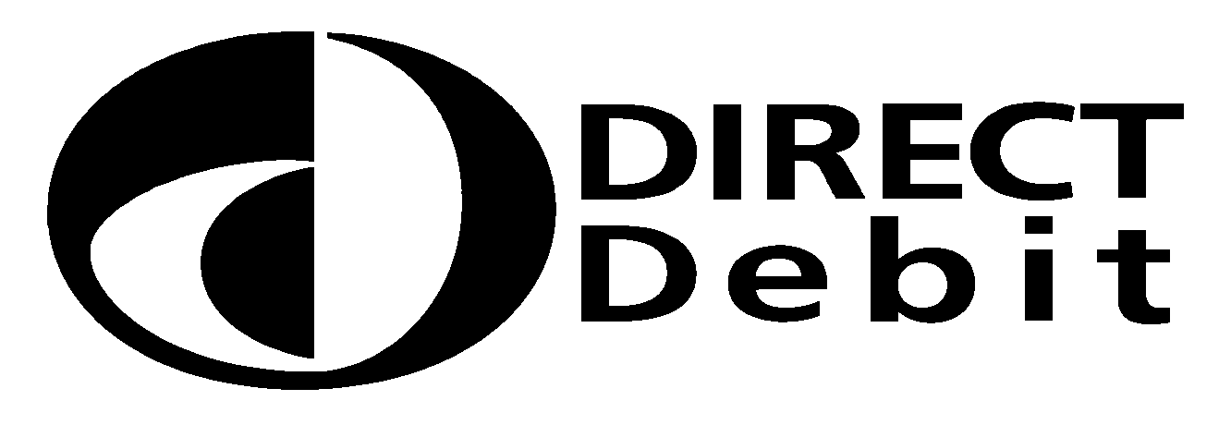

Direct Debit is the method preferred by the Council as there are considerable cost savings involved. If you wish to pay by Direct Debit please complete and return this form. Alternatively, you may set up your Direct Debit over the telephone on 020 8547 5000.

Instruction to your bank or building society to pay by Direct Debit

Please return the completed form by email to us at nndr@kingston.gov.uk or bids1@kingston.gov.uk and quote your account number in the subject line. Please do not return this form to your Bank or Building Society.

Name and full address of your bank or building society
Originator’s Identification Number:
624590
Bank or building society:

Address:

National Non Domestic Rates/BIDS Account Number

Postcode:

Instructions to your bank or building society

Please pay The Royal Borough of Kingston upon Thames Direct Debits from the account detailed in this instruction subject to the safeguards assured by the Direct Debit guarantee.
I understand that this instruction may remain with The Royal Borough of Kingston upon Thames and, if so, details will be passed electronically to my bank / building society.

Please pay The Royal Borough of Kingston upon Thames Direct Debits from the account detailed in this instruction subject to the safeguards assured by the Direct Debit guarantee.

I understand that this instruction may remain with The Royal Borough of Kingston upon Thames and, if so, details will be passed electronically to my Bank / Building Society.

Name(s) of account holder(s)

Bank or building society account number
Signature(s)

Branch sort code
Date

Banks and building societies may not accept Direct Debit instructions for some types of account

FOR RBK CUSTOMER USE ONLY (This is not part of the instruction to your bank or building society)

Please tick the appropriate box to select your instalment date:

1st day of each month Half-yearly: 1st April followed by 1st Sept
15th day of each month Annually on 1st April
FOR RBK CUSTOMER USE ONL FOR RBK CUSTOMER USE ONLY

...................................................................................................................................................................……………

The Direct Debit Guarantee
This guarantee should be detached and retained by the payer.
- This Guarantee is offered by all banks and building societies that accept instructions to pay Direct Debits.
- If there are any changes to the amount, date or frequency of your Direct Debit, The Royal Borough of Kingston will notify you 10 working days in advance of your account debited or as otherwise agreed. If you request The Royal Borough of Kingston to collect a payment, confirmation of the amount and date will be given to you at the time of the request.
- If an error is made in the payment of your Direct Debit, by The Royal Borough of Kingston or your bank or building society, you are entitled to a full and immediate refund of the amount paid from your bank or building society.
- If you receive a refund you are not entitled to, you must pay it back when The Royal Borough of Kingston asks you to.
- You can cancel a Direct Debit at any time by simply contacting your bank or building society. Written confirmation may also be required. Please also notify us.

