Getting in touch with us

If you need to contact the Council to discuss your account, please quote your account number as shown on the front of this Reminder Notice. If you are writing to us, please provide a contact telephone number.

Website www.kingston.gov.uk

Email ctax@kingston.gov.uk
Telephone 020 8547 5000 - 9am to 5pm Monday to Friday

In person Revenues Department, Royal Borough of Kingston, Guildhall 2, Kingston upon Thames, Surrey, KT1 1EU. Appointment basis only.

Where possible, send to the email address shown above, scanned images or photographs of all documents you wish to submit.

Register online to view your account

www.kingston.gov.uk/viewyourbill

Making Payments

Website and Direct Debit
Go to www.kingston.gov.uk to pay your Council Tax online, 24 hours a day, 365 days a year by debit or credit card. The latest technology is used to make your payment fully secure. You can also set up a Direct Debit online.

Telephone Payments
Payment by debit or credit card may be made using the Council's Automated Telephone Payment facility on 0345 359 1111. Touch-tone telephone keypads are required. This service is available 24 hours a day, 365 days per year.

Bank Standing Order
You should obtain the necessary forms from your bank, instructing them to pay The Royal Borough of Kingston upon Thames. Use the following bank details: Lloyds Bank, Sort Code 30-80-12 Account Number 14717168. Always quote your Council Tax account number shown on your bill. The completed form should be returned direct to your bank. It is the Council Tax payer's responsibility to ensure that the standing order is paid on time and for the right amount.

By Telephone Banking
Use the following account details: Lloyds Bank, Sort Code 30-80-12 Account Number 14717168. Please quote your name and Council Tax account number.

At the Post Office
Payment can be made at any Post Office - cash and debit cards are acceptable. Present your payment and the barcode shown on the front of your bill to the counter clerk. You will receive a receipt for the transaction which you should retain for your records. Your barcoded document will be returned to you for use next time. There is no fee charged to you for this transaction. Please allow 4 working days for the Council to receive this payment.

Payzone

Payment can be made at any Payzone bill payment outlet - cash only payments are acceptable. Present your payment and the barcode shown on the front of your bill to the counter clerk. You will receive a receipt for the transaction which you should retain for your records. Your barcoded document will be returned to you for use next time. There is no fee charged to you for this transaction. Please allow 4 working days for the Council to receive this payment.

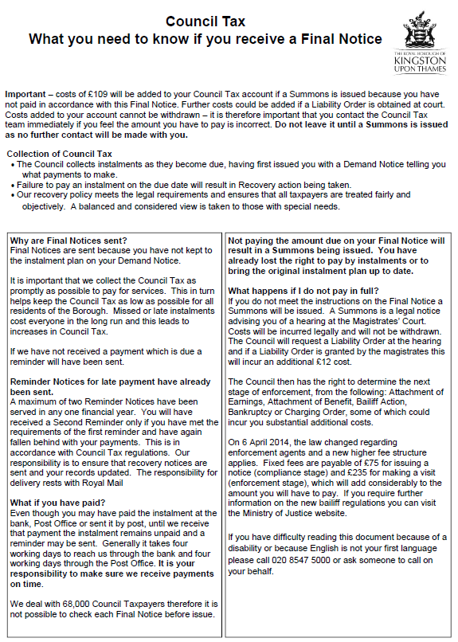

If you are finding it difficult to pay your Council Tax bill or manage your money, you may find the advice on our website at www.kingston.gov.uk useful. There is further information and advice available at www.moneyadviceservice.org.uk and www.gov.uk

If you live in the borough and you are on a low income you may qualify for Housing Benefit (HB)
or a Council Tax Reduction (CTR), or you may qualify for both. Use our online benefits calculator and claim form to see how much HB or CTR you could get. You can find our online benefits calculator at www.kingston.gov.uk/benefits

The maximum reduction you can receive is 100% of your Council Tax liability but this depends on factors such as your income, savings and the size of your household.

If you rent a property or room from a private landlord, the amount of Housing Benefit you receive may be set by the Local Housing Allowance (LHA). This may be lower than your actual rent. The LHA is dependent on where you live as well as the size of your household. Please visit our website for more information at www.kingston.gov.uk/benefits

The maximum amount of HB you would receive will be restricted by the relevant LHA rate. The actual amount of HB will depend on factors such as your income, savings and the size of your household.

If you rent a property from Kingston Council or a Housing Association (also known as a Registered Social Landlord) the maximum HB you can usually receive will be 100% of the weekly eligible rent. HB cannot take service charges into account such as amounts towards heating, lighting and water rates. However, if you have more bedrooms than you need for your household the maximum amount of HB you can receive will be restricted. The actual amount of HB will depend on factors such as your income, savings and the size of your household.

If you are on a low income you may be able to claim benefits such as Jobseeker’s Allowance, Income Support or Employment and Support Allowance. Please call Jobcentre Plus on 0800 055 6688 for more information. If you have reached State Pension Credit age you may be entitled to Pension Credit, please call 0800 99 1234 for more information. You can also find information about all of these benefits at www.gov.uk

If you are on a low income you may be entitled to Tax Credits. You do not need to have children to qualify for Working Tax Credit. Please visit www.hmrc.gov.uk or call 0345 300 3900 for more information. There is an online calculator which will estimate how much Tax Credit you may be entitled to.
Help to pay your Rent and/or Council Tax

Citizens Advice Bureau
www.adviceguide.org.uk or
For England: 03444 111 444 / 020 3166 0953
For Wales: 03444 77 20 20 / 020 8185 0717.

Please note there is a charge for calling these numbers

Gov.uk at www.gov.uk
Other free advice is available

AdviceUK
www.adviceuk.org.uk

National Debtline
www.nationaldebtline.org
0800 804 4000

Money Advice Service www.moneyadviceservice.org.uk
0800 138 7777
0800 804 4000
For independent advice on debt problems

