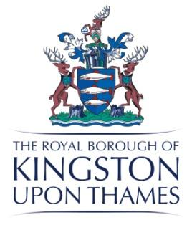
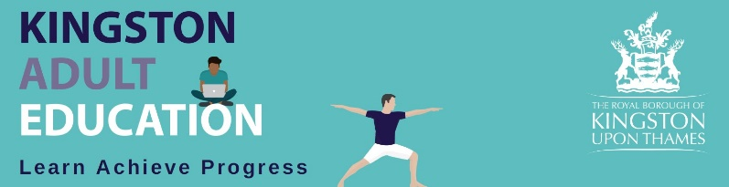

K A E Governors’ Advisory Board
A meeting was held on Wednesday 26th January 2022
at 6.30pm
in Virtual meeting

Present: | Apologies:
Hilda Clarke - HC (Chair)  Sam Burgess - SB  Lesley Searle - LS  Rebbecca Roberts - RR  Barry Avery- BA  Nicky Morris - NM  Sarah Jordan - Clerk to Governors - SJ | Councillor Kim Bailey - KB  Michael Hill – MH (Vice)  Roger Weatherhead - RW  Jo Moulton – JM  Dennis Clarke - DC
- Welcome to our new Student Governor Dennis Clarke HC
HC welcomed Dennis Clarke our new student governor to the board. He is a long standing student of KAE and we look forward to working with him.
- Minutes of last meeting Approved

- Matters Arising and Declarations of Interest
No matters arising
No declarations of interest

3 Report by the Principal

SB reviewed her report.
Enrolments
This year’s enrolments are up 19% at 1451 on last year. Although this is positive it is still a long way down on pre lockdown enrolments. The Service is approximately 36% (850 learners) down on pre Covid levels. Some of this shortfall is due to the inability for us to offer ceramics, sculpture and upholstery.

Service Update
- KAE Independent Review – the consultants Social Financing have met with a number of KAE stakeholders. It is encouraging to see that some of their initial findings are in alignment with our strategy. There has been some discussion about KAE keeping any surplus it manages to generate which would be very positive. Any recommendations made are not mandatory and the Council can decide if they want to adopt them or not.
- Future Culture & Heritage Transformation – Phase 1 is complete with the new managers being recruited. Phase 2 is to restructure the area and is due to be completed in March. It is highly likely that this date will be delayed.
- Ofsted Inspection – We have no further information on this. We are anticipating an inspection between now and 2024.
- SAR – The workshop with staff has taken place and the data collated. The SAR will be finalised and published in February.
- MIS-REMS – This is a completely new system and its installation has taken longer than anticipated. It is gradually coming on line with registers and will be in place for the new academic year in April.

Achievements and Retention 2020/21
Achievement rates are down in the 16-18 category but up in the other areas. Overall, the achievement has improved since 2019/20 which is an excellent result.
Retention across the board has improved from 2019/20.

Mental Wellbeing Staff Survey
89% of staff reported their mental wellbeing as being between average and excellent. This is a slight improvement on 2020/21. The survey results have by in large improved.
Do you have the necessary tools to do your job effectively? This question although the response has improved on last year it is still at approximately 70% which is not where we want it to be.
Are you working over your contracted hours? This has also increased in % terms but not in actual terms.
These results are being looked at carefully so that the areas of concern can be improved upon.

Starters and Leavers
SB announced the very sad news that Pam Wardley our making clothes tutor has died.
We have a number of new starters including Tiba Sarheed who will be an ESOL officer. This will be the first time we have had 2 ESOL officers and should be a big help to the department.
In addition to the new starters there are a number of roles that are currently being recruited for. The SSL Manager, CL Officer and 3 tutors.

LS - Commented how she was concerned about the pressure staff are under. They are concerned about the future of KAE and the perceived lack of RBK support. There is also a concern about the Hillcroft College expansion and the fact that KAE don’t have a base.

HC – responded by agreeing with LS and making clear how strongly these views were expressed to the consultants. It was strongly stated that KAE need a permanent base.

SB – suggested the Jam board be re-opened for staff to note their concerns for the consultants.

Action – the Jam board to be reopened for staff so they can continue to add their concerns for the Consultants. SB

LS – Agreed that it would be good if staff could continue to add to the list of concerns they have for the consultants.

NM – commented how issues don’t seem to be resolved so quickly when we are operating online or in a hybrid manner. There is less face to face communication and this seems to elongate problem resolution.

Chairman’s Report
HC discussed her report.
There was a 1 hr meeting between some Governors and the Consultants involved in the Independent Review.
Four main areas were discussed

- The need for a base for KAE.
A base is needed for the SLT, exams and administration to have a centre. To allow guidance and support services to learners to have meeting rooms. To provide drop in work and meeting spaces for staff and students. Without space and identity KAE will not be efficient and attractive to staff and learners. All our neighbouring AE providers have a fixed base. People want decent places to work and study in – too many of the current locations are of poor quality, poor facilities and temporary.

- Delivery model
The hybrid model is working but space is needed so that practical courses have specialist rooms and then can be offered to learners. We need the ability to teach these courses during the day and evenings.

- KAE need to sit in Public Health
This is the most appropriate place that will offer the best support to KAE to help it fulfil its potential.

- KAE is an entry point into Education for many learners and those returning to education, work or training. KAE needs to provide private courses for all in the community across a broad range of areas. Raising the private income is important to raising revenue for KAE.

BA – commented how we stressed how nimble KAE was and how we are keen to work with all different groups.
HC – agreed with this. She has invited the consultants to come to Kingston and see the premises we are operating from and how poor some of them are. She also highlighted the discussion about finances and the logic of KAE producing a surplus and not keeping it. Also the budget setting process how unrealistic this is. The group were optimistic about the future of KAE as long as they receive support from the Council.

AOB
HC and SB will be at the funeral of Pam Wardley representing KAE.
The next meeting is Wednesday May 25th and we will plan to have it as a face to face meeting.
Action SJ to book a room in the Guildhall.

The meeting concluded at 7.07pm

